Design Document – All in One Application

Description:

All in one is a web application. Main features of this application are online shopping, mobile recharge and money transfer.

Screens:

User has to register with their mobile number or email id to use the application. Once registration is completed, user can login to the application.

Login Page

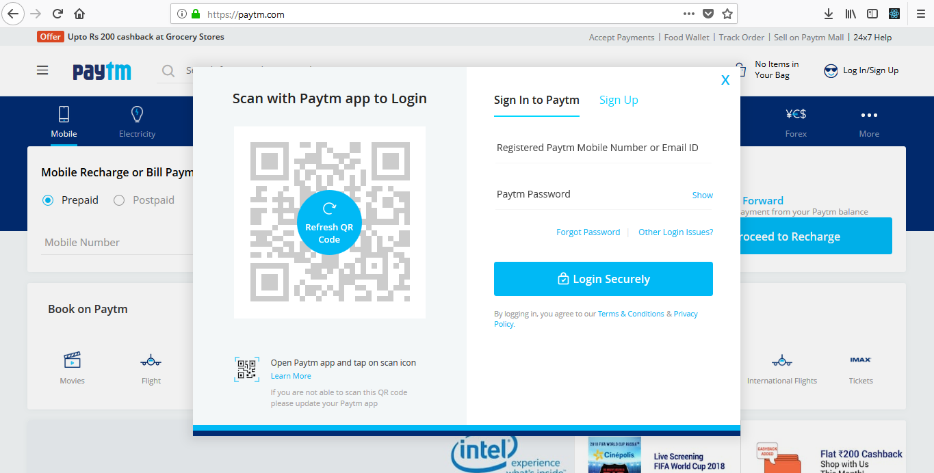

Mobile recharge:

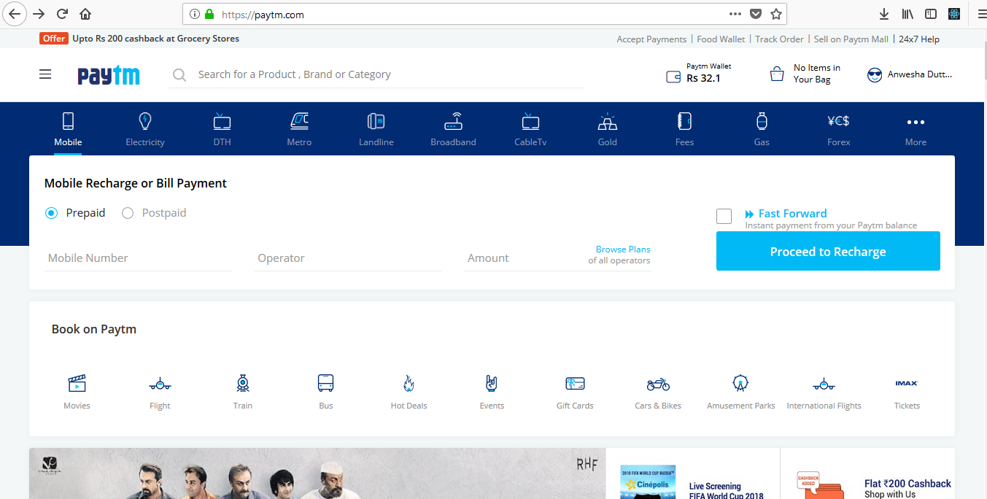

Fund transfer:

Screen pending.

Online transaction:

